State of NM Child Support Enforcement System Replacement (CSESR) Project

Instructions for Responding to this Request
for Quote (RFQ) CSESR PMO
Date: January 3, 2023

Table of Contents
Table of Contents
Table of Contents 2
1.0 Purpose 3
2.0 Quote Schedule 3
3.0 Response Format and Organization 3
4.0 Contract Manager 4
5.0 Quote Format 4
5.1.1 Formatting Instructions 4
5.1.2 Outline 5
6.0 Contractor Qualifications 6
7.0 Scoring Criteria 6
8.0 Legal Evaluation of Statement of Work 7
9.0 Evaluation 7
9.1 Oral Presentation 7
9.2 Evaluation Factors 7
10.0 Appendix 8
10.1 Appendix A: List of Acronyms 8
10.2 Appendix B: HSD Project Organizational Chart 9
10.3 Appendix C: HSD Responsibilities 9

1.0 Purpose
The New Mexico (NM) Human Services Department (HSD) is interested in procuring Project Management Office services related to its current Child Support Enforcement System Replacement (CSESR) Project. The HSD is requesting quotes from contractors who hold a current State-Wide Price Agreement (SWPA) or General Services Agreement (GSA) for the provision of Information Technology (IT) Professional Services, Project Management Services or other applicable price agreement categories.
This engagement resulting from this Request for Quote (RFQ) will form the central project management component of the CSESR project. Contractors should inform themselves regarding these projects by reading the overview approach below.
The instructions and information below are intended to assist the contractors in pricing a quote for the HSD evaluation.
The contact type classification for this work is “Firm Fixed Price”.

2.0 Quote Schedule
The Contract Manager will make every effort to adhere to the following schedule:

Action | Responsible Party | Due Date*
1. Issue RFQ | HSD | 1/3/23
2. Deadline to Submit Questions (by email) | Potential Contractors | 1/17/23
3. Response to Questions | HSD | 1/24/23
4. Submission of Quotes | Contractors | 2/14/23
5. Selection of Finalists | HSD Selection Committee | 2/28/23
6. Selection of Contractor | HSD Selection Committee | 3/7/23
* Dates subject to change based on number of responses and final approval from federal partners.

3.0 Response Format and Organization
Number of Responses
Each Contractor shall submit only one (1) response to this RFQ.

Response Files
Each Contractor shall deliver, by single electronic mail, the following files to the HSD Contract Manager. The total file size must not exceed 20MB.
Part A Technical Approach: one electronically signed pdf file and the corresponding MS Word Document. Part A must not include any cost information.
File Name = Contractor_Name_Part_A_Technical_Approach (PDF and .doc)
Part B Quote Budget: one electronically signed pdf file and the corresponding MS Word Document. Submit the Quote Budget Form only.
File Name; Contractor_Name_Part_B_Quote_Budget (PDF and .doc)
All files must be received by the Contract Manager no later than 3:00 PM (Mountain Time) on the date of submission as per the Quote Schedule. Contractors are advised to use an email return request confirmation. Any response that does not adhere to the requirements of this section may be deemed non-responsive and may be rejected on that basis.

4.0 Contract Manager
The Contract Manager for this RFQ is David Martell. All submissions and any other needed communication must be directed to the Contract Manager, David Martell, david.martell@hsd.nm.gov

5.0 Quote Format
This section describes the required format, content, and organization for all quotes.

Part A: Technical Approach
The work of this engagement is organized into four (4) key deliverables of project management expertise.
Part A: Technical Approach must follow the outline, page limits and page formatting instructions detailed below.

Formatting Instructions
Font: Calibri eleven (11) point
Spacing: Single
Margins: One-inch margins on all sides Paper: 8 1/2 X 11
Header: Contractor Name
Footer: Page number

Outline
Cover or Title Page Table of Contents
Summary of corporate and overall approach to the engagement objectives. The summary must include a statement of experience with projects related to state Child Support Enforcement (IV-D) agencies including creation of Advanced Planning Documents, Feasibility Studies and procurement documents such as Requests for Proposals. (Limit 2 pages) While HSD is asking for page limited summaries of experience and qualifications, we may ask for further information or clarifications on the submitted proposal during the selection process.

For each Deliverable within the Statement of Work (Limit 2 pages per deliverable)
Response to Deliverable
Response to Specific Experience
Approach to Deliverables and Methods for Success
Reference Contact Information

Additionally, an Appendix is required of Key Staff Resumes of personnel to be assigned to this project. Each Key Resume should list the assigned role from Article 12 of the Statement of Work. (Limit 1 page per resume)
Part B: Quote Budget
The HSD is asking for a separate fixed price quote, including NM Gross Receipts Tax for each Deliverable of the Statement of Work. The HSD has included duration estimates on the completion of each deliverable, but these estimates are the agency’s estimate only. Contractors will utilize their previous experience and expertise to determine the proposed duration for each of the deliverables.
Quotes should be all inclusive of contractor costs that will be charged the HSD.

Deliverable Name | Duration Estimate | Cost Estimate
1.0 CSESR Project Plans | 1 month
1.1 Ongoing Project Management, per month | Each month (36 months total)
2. Streamlined Feasibility Study | 3 months
3. CSESR Implementation Advanced Planning Document (IAPD) | 3 months
4. CSESR RFP Development and Procurement Support | 9 months

Contractor Qualifications
The Human Services Department (HSD) requires any organization awarded the CSESR Project Management Office contract possess the necessary resources, knowledge, business techniques, and technical abilities to manage the project from Planning phase through Implementation Phase.
Within the Contractor’s Technical Approach of the submitted quote, defined in section 5.1.2 above, Contractor must make clear the qualifications and experience that the Contractor possesses to complete all deliverables within the Response to Specific Experience. Additionally, the Reference Contact Information should tie directly to the experience stated within the Response to Specific Experience.
Specific areas of expertise that the HSD is seeking include, but are not limited to:
- Child Support Enforcement System modernization efforts
- Feasibility Study and Alternatives Analysis creation
- Advanced Planning Document creation
- Requests for Proposal (RFP) creation and subsequent procurement activities
- Ongoing project management experience of a system modernization or replacement project, from planning phase through design, development, and implementation phases.
For each of these specific areas of expertise, please provide the total number of projects, the number of projects related to public sector organizations, size of the projects (by total dollars and/or personnel) and complexity. Please use a table to summarize this information.

Scoring Criteria
HSD will score the quotes received by contractors across four (4) categories weighted by the factors in the table, below. HSD will use a consensus scoring approach among the committee chosen to evaluate the quotes.

Quote Category | Weighted Score range
Technical Approach | 0 to 300 points
Budget | 0 to 300 points
Experience | 0 to 200 points
Key Staff Resumes | 0 to 200 points
Total | 0 to 1,000 points

Legal Evaluation of Statement of Work
To speed contract negotiations once evaluation of all proposals are complete, HSD also requests that the Contractor provide a summary, maximum 2 pages, of any terms and conditions of the SOW that are not acceptable to the Contractor, as written.

Evaluation

Oral Presentation
HSD may select finalists and may invite finalists to present an overview of its quote to the Evaluation Committee and to answer the HSD questions to clarify costs and service quoted.

Evaluation Factors
All quotes will be evaluated for the perceived benefit related to the purposes of this RFQ as described in the Invitation to Quote document. The Contractor quote that is most advantageous to the HSD will be considered for award. Please note, however, that, regardless of overall score, a serious deficiency in the response to any one factor may be grounds for rejection. The contract award will go to the finalist deemed to be the most advantageous to and of best value to the HSD for the requested work.

Appendix

Appendix A: List of Acronyms
A list of acronyms is provided below:

Acronym | Definition
ACF | The Administration for Children and Families
ASPEN | Automated System Program and Eligibility Network
CSESR | Child Support Enforcement System Replacement
DS | Data Services Platform
ECM | Electronic Content Management
GSA | US General Services Administration Schedule
HHS | Health and Human Services
HHS 2020 | Health and Human Services 2020 Initiative
HSD | Human Services Department
IAPD | Implementation Advance Planning Document
IT | Information Technology
LD | Liquidated Damages
MMIS | Medicaid Management Information System
Multi-Ops APD | Multiple Operations Advance Planning Document
NASPO | National Association of State Procurement Officials
NM | New Mexico
NMGRT | New Mexico Gross Receipts Tax
NoSQL | Not Only Structured Query Language
OCSE | Office of Child Support Enforcement
OIG | Office of Inspector General
PAPD | Planning Advance Planning Document
PMO | Project Management Office
RFP | Request for proposal
RFQ | Request for Quote
SI | System Integration Platform
SLA | Service Level Agreements
SWPA | New Mexico State-Wide Pricing Agreement
UPI | Unified Public Interface

Appendix B: HSD Project Organizational Chart

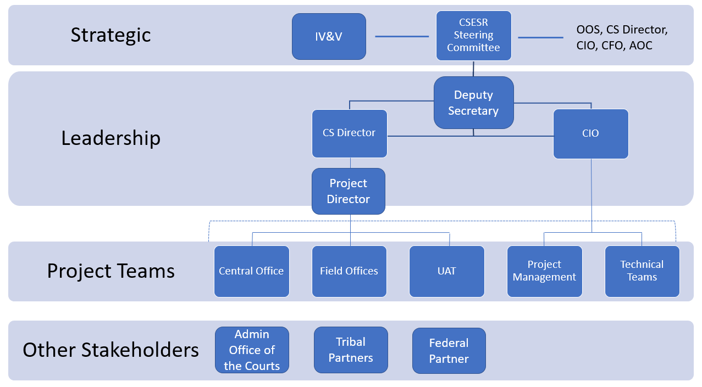

Appendix C: HSD Responsibilities

Executive Steering Committee (Voting Members)
Title / Role | Responsibilities
Deputy Secretary | Authorizing changes to Scope, Schedule and Budget
Chief Information Officer | Authorizing changes to Scope, Schedule and Budget
Acting IV-D Director | Authorizing changes to Scope, Schedule and Budget
Project Director | Executive Oversight of Project
Project Team
Title / Role | Responsibilities
IT Project Manager | Project Management and oversight of contractor. Review and approve deliverables.
ITD System Admin Bureau Chief | HSD system administration and network services. Review and approve deliverables.
CSES Technical Lead | CSES Subject Matter Expert (SME). Review and approve deliverables.
CSED Programs Bureau Chief | CSED SME. Review and approve deliverables.
CSED Business Project Lead | CSED SME. Review and approve deliverables.
Contract Manager | Contract Manager. Fulfill all contract manager functions.

